**Module(CSS AND CSS-3)-2**

**1).What are the benefits of using CSS?**

**Ans.**

**Benefits:-**

* CSS(Cascading style sheet) is used to presenting attractive web pages.
* CSS reduces the file transfer size.
* Easy for the user to customize the page online.
* Easy to presenting different style to different viewers.
* Easy maintenance of multiple pages.
* Easy to learn the css.

**2).What are the disadvantages of CSS?**

**Ans.**

**Disadvantages:-**

* CSS has so many unique properties and values that must be correctly understood and applied, it can be difficult to learn.
* Larger CSS file can impact on perform of web pages because of large CSS file it increases the load time and less responsive for user interface.

**3).What is the difference between CSS2 and CSS3?**

**Ans.**

|  |  |
| --- | --- |
| CSS2 | CSS3 |
| CSS2 had a Normally styling | CSS3 had Better styling then CSS2. |
| CSS2 Doesn’t support border-box property. | CSS3 supports the Border-Box property. |
| There is no backward compatibility with CSS2. | There is backward compatibility Maintained with CSS3. |
| CSS2 support Web-safe fonts. | CSS3 support special fonts. |

**4).Name a few CSS style components.**

**Ans.**

* Color :- sets the color of text.
* Font-size :- set the font-size of the font.
* Background-color :- set the background color in the background.
* Width :- for set the width of the contain.
* Height :- set the height of the contain.
* Margin :- set the form space out of box.

**5).What do you understand by CSS opacity?**

**Ans.**

* The css opacity is used to specify the transparency of an element.
* Opacity will use between 0 and 1.
* In opacity 0 is completely transparent. And 1 is no transparent.
* **Code:-**

<!DOCTYPE html>

<html lang="en">

<head>

    <meta charset="UTF-8">

    <meta http-equiv="X-UA-Compatible" content="IE=edge">

    <meta name="viewport" content="width=device-width, initial-scale=1.0">

    <title>Document</title>

    <style>

        img{

            opacity: 0.5;

        }

    </style>

</head>

<body>

    <img src="london.jpg" alt="">

</body>

</html>

**Output:-**

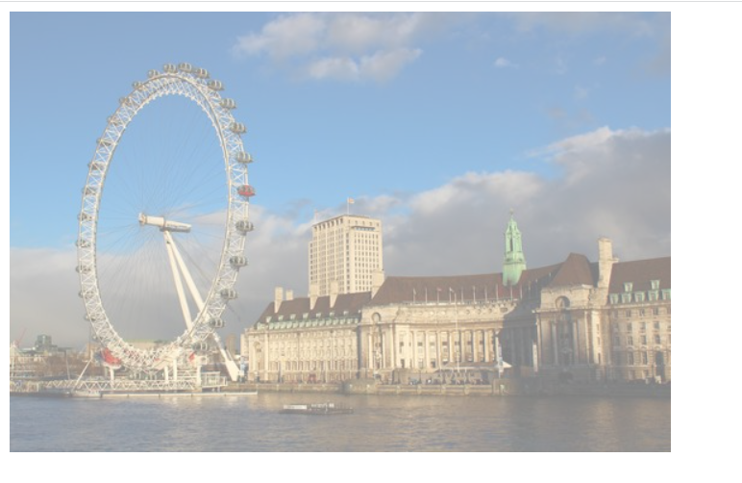

**6).How can the background color of an element be changed?**

**Ans.**

* For set the background color use the style attributes in Head tag.
* Css style is used for add background color in body tag.
* D
* **Code:-**

<!DOCTYPE html>

<html lang="en">

<head>

    <meta charset="UTF-8">

    <meta http-equiv="X-UA-Compatible" content="IE=edge">

    <meta name="viewport" content="width=device-width, initial-scale=1.0">

    <title>Document</title>

    <style>

      div{

        height: 250px;

        width: 250px;

        background-color: aqua;

      }

    </style>

</head>

<body>

    <div></div>

</body>

</html>

**Output:-**



**7).How can image repetition of the backup be controlled?**

**Ans.**

* Image Repetition of backup control using the background-Repeat property.
* In that property you can use no-repeat value for no repeat an image.
* You can also use repeat, repeat-x, repeat-y, round, space, unset.
* **Code:-**

<!DOCTYPE html>

<html lang="en">

<head>

    <meta charset="UTF-8">

    <meta http-equiv="X-UA-Compatible" content="IE=edge">

    <meta name="viewport" content="width=device-width, initial-scale=1.0">

    <title>Document</title>

    <style>

      div{

        height: 500px;

        width: 1000px;

        background-color: red;

        background-image: url(london.jpg);

        background-repeat: no-repeat;

      }

    </style>

</head>

<body>

    <div></div>

</body>

</html>

**Output:-**



**8).What is the use of the background-position property?**

**Ans.**

* Background-position property is use for make the perfect position of a background Image.
* In Background-position we will use in center, top, bottom, left, right, etc.
* **Code:-**

<!DOCTYPE html>

<html lang="en">

<head>

    <meta charset="UTF-8">

    <meta http-equiv="X-UA-Compatible" content="IE=edge">

    <meta name="viewport" content="width=device-width, initial-scale=1.0">

    <title>Document</title>

    <style>

      div{

        height: 500px;

        width: 1000px;

        background-color: red;

        background-image: url(london.jpg);

        background-repeat: no-repeat;

        background-position: center;

      }

    </style>

</head>

<body>

    <div></div>

</body>

</html>

**Output:-**

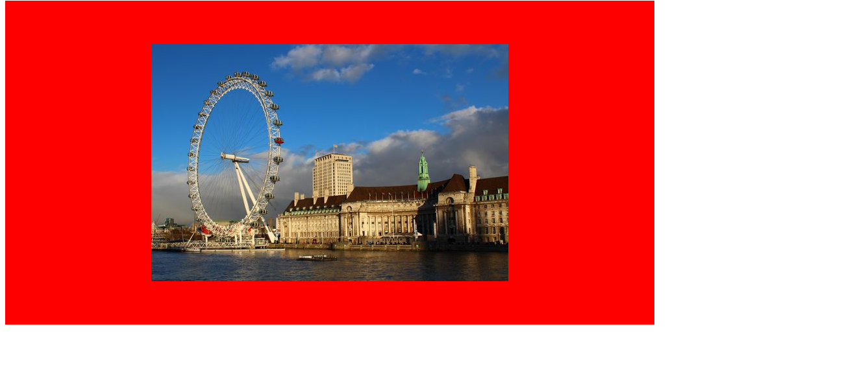

**9).Which property controls the image scroll in the background?**

**Ans.**

* Image scroll is
* **Code:-**

<!DOCTYPE html>

<html lang="en">

<head>

    <meta charset="UTF-8">

    <meta http-equiv="X-UA-Compatible" content="IE=edge">

    <meta name="viewport" content="width=device-width, initial-scale=1.0">

    <title>Document</title>

    <style>

        .one{

            height: 100px;

            width: 200px;

            background-color: brown;

            border-radius: 0;

            overflow: auto;

        }

    </style>

</head>

<body>

    <p class="one">Lorem ipsum dolor sit amet consectetur adipisicing elit. Culpa, quas? Suscipit harum, distinctio fugit dicta expedita, autem officia nisi voluptates numquam architecto quidem? Architecto assumenda eaque sequi sapiente, neque saepe?</p>

</body>

</html>

**Output:-**

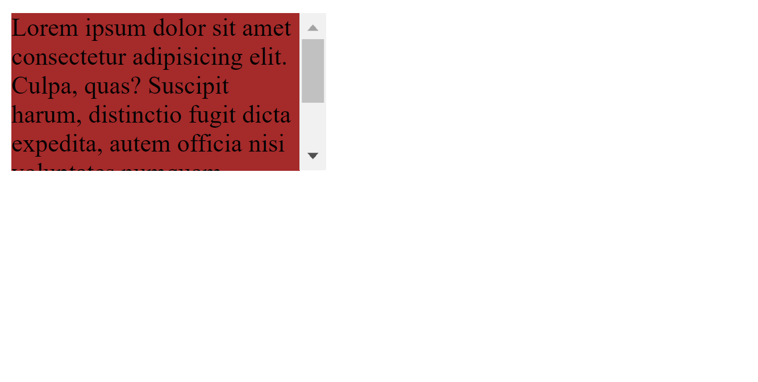

**10).Why should background and color be used as separate properties?**

**Ans.**

* The Background property is complex property in CSS. If Background Property is combined with color. The color complexity will further increase.
* Background property is used for giving the all method in background.
* Color property is used for giving color in font.
* **Code:-**

<!DOCTYPE html>

<html lang="en">

<head>

    <meta charset="UTF-8">

    <meta http-equiv="X-UA-Compatible" content="IE=edge">

    <meta name="viewport" content="width=device-width, initial-scale=1.0">

    <title>Document</title>

    <style>

      div{

        background-color: red;

        color: chartreuse;

        text-align: center;

        font-size: xx-large;

      }

    </style>

</head>

<body>

    <div>Prajapati</div>

</body>

</html>

**Output:-**



**11).How to center block elements using CSS1?**

**Ans.**

* Using the shown below methods to Center the block elements in CSS1 method :

1. Using text-align center to center the block element.
2. Using the <center> tag.

* **Code:-**

<!DOCTYPE html>

<html lang="en">

<head>

    <meta charset="UTF-8">

    <meta http-equiv="X-UA-Compatible" content="IE=edge">

    <meta name="viewport" content="width=device-width, initial-scale=1.0">

    <title>Document</title>

    <style>

      .one{

        background-color: red;

        text-align: center;

        font-size: 40px;

      }

      h1{

        color: brown;

      }

    </style>

</head>

<body>

    <div class="one">Prajapati</div>

    <center>

      <h1>Mann</h1>

    </center>

</body>

</html>

**Output:-**



**12).How to maintain the CSS specifications?**

**Ans.**

* W3C(World Wide Web Consortium) is maintain the CSS Specification.

1. Use valid CSS :

Ensure that your code writing in the valid Css format. Validate your CSS code using the tool like the W3C validation service.

1. Browser compatibility :

Test your code with different browser and platform to ensure compatibility.

1. Test and Debug :

Regularly test the CSS code with different browsers and devices.

**13).What are the ways to integrate CSS as a web page?**

**Ans.**

* There are three ways to integrate the Css as a Web page.

1. Inline CSS :

In Inline css placing the css directly use in the “style” attributes.

Ex. :-

 <p style="background-color: cadetblue; color: chartreuse; font-size: 50px; text-align: center;">Prajapati</p>

1. Internal CSS :

In Internal css defined in the <style> tag in the head tag.

Ex. :-

<!DOCTYPE html>

<html lang="en">

<head>

    <meta charset="UTF-8">

    <meta http-equiv="X-UA-Compatible" content="IE=edge">

    <meta name="viewport" content="width=device-width, initial-scale=1.0">

    <title>Document</title>

    <style>

      .one{

        background-color: red;

        text-align: center;

        font-size: 40px;

        color: chartreuse;

      }

    </style>

</head>

<body>

    <div class="one">Prajapati</div>

</body>

</html>

1. External CSS :

In External css defining with make the another css file. And link with the <link> tag add in <head> tag portion of the html file.

Ex. :

.HTML :-

<!DOCTYPE html>

<html lang="en">

<head>

    <meta charset="UTF-8">

    <meta http-equiv="X-UA-Compatible" content="IE=edge">

    <meta name="viewport" content="width=device-width, initial-scale=1.0">

    <title>Document</title>

    <link rel="stylesheet" href="10.css-grid.css">

</head>

<body>

    <div>

        <div class="one">Mann</div>

    </div>

</body>

</html>

.CSS :-

.one{

    color: chocolate;

    font-size: large;

    text-align: center;

}

**14).What is embedded style sheets?**

**Ans.**

* Embedded style sheet also known as internal CSS.
* With an embedded style sheet, you define the styles that apply to specific HTML elements or class within the same document.
* It defining CSS rules directly within the ‘<style>’ tags in the ‘<head>’ section of an HTML file.
* **Code:-**

<!DOCTYPE html>

<html lang="en">

<head>

    <meta charset="UTF-8">

    <meta http-equiv="X-UA-Compatible" content="IE=edge">

    <meta name="viewport" content="width=device-width, initial-scale=1.0">

    <title>Document</title>

    <style>

      .one{

        background-color: red;

        text-align: center;

        font-size: 40px;

        color: chartreuse;

      }

    </style>

</head>

<body>

    <div class="one">Prajapati</div>

</body>

</html>

**Output:-**



**15).What are the external style sheets?**

**Ans.**

* In External css defining with make the another css file. And link with the <link> tag add in <head> tag portion of the html file.
* **Code:-**

.HTML :-

<!DOCTYPE html>

<html lang="en">

<head>

    <meta charset="UTF-8">

    <meta http-equiv="X-UA-Compatible" content="IE=edge">

    <meta name="viewport" content="width=device-width, initial-scale=1.0">

    <title>Document</title>

    <link rel="stylesheet" href="10.css-grid.css">

</head>

<body>

    <div>

        <div class="one">Mann</div>

    </div>

</body>

</html>

.CSS :-

.one{

    color: chocolate;

    font-size: large;

    text-align: center;

}

**16).What are the advantages and disadvantages of using external style sheets?**

**Ans.**

* **Advantages :**
* External stylesheet promote a clear separation between the html and CSS of a web page.
* External style sheets can be used across multiple html pages.by linking the same CSS file to different documents.
* Using external style sheets allow multiple developers to work on the HTML and CSS separately.
* **Disadvantages :**
* using external stylesheet, the browser needs to make an additional HTTP request to retrieve the CSS file.
* External style sheets can increase the initial page load time.
* External style sheet require a separate CSS file to be present and accessible .if the file is missing and the link is incorrect, the style will not be applied correctly.

**17).What is the meaning of the CSS selector?**

**Ans.**

* CSS Selector can target element in various types like class, id, tags.

1. Class selector: it targets all the class of elements and apply same style on all class given by you. Class selector is declared with ‘.’ .

Ex. :

.one{

        background-color: red;

        text-align: center;

        font-size: 40px;

        color: chartreuse;

      }

1. Id selector: it targets element based on their unique id attribute. it is declared with ‘#’.

Ex. :

#one{

        background-color: red;

        text-align: center;

        font-size: 40px;

        color: chartreuse;

      }

1. Universal selector: it targets all html code. And apply style in all html code. Universal selector will declared with ‘ * ’.

Ex. :

 *{

            margin: 0;

            padding: 0;

        }

**18).What are the media types allowed by CSS?**

**Ans.**

* Media types represent different output or media types.
* The following media types allowed by CSS.

1. All: This is the default media type it is applies to all devices.
2. Screen: This media type is used for computer screen, tablet and smart phones.

**19).What is the rule set?**

**Ans.**

* The rule set is main building block of CSS style sheet.
* Rule set consists of a set of rules that determine how elements in a document should be displayed.
* The rule set is also known as Css-rule or style-rule.
* Rule set contains selector and declaration of one or more property and value.

**20).Create Layouts**

**Ans.**

* **Code:-**

<!DOCTYPE html>

<html lang="en">

<head>

    <meta charset="UTF-8">

    <meta http-equiv="X-UA-Compatible" content="IE=edge">

    <meta name="viewport" content="width=device-width, initial-scale=1.0">

    <title>Document</title>

    <style>

        *{

            margin: 0;

            padding: 0;

            box-sizing: border-box;

            background-color: whitesmoke;

        }

        #one{

            height: 100vh;

            width: 100%;

        }

        #two{

            display: flex;

            justify-content: space-around;

        }

        #three{

            display: flex;

            justify-content: space-around;

        }

        .one,.two{

            height: 300px;

            width: 470px;

            background-color: white;

            margin-top: 20px;

        }

        .three{

            height: 150px;

            background-color: rgb(77, 80, 80);

            color: white;

            font-size: xx-large;

            font-weight: bolder;

            padding-top: 50px;

            padding-left: 150px;

        }

        .four{

            background: none;

            font-family: Arial, Helvetica, sans-serif;

        }

        .five{

            background: none;

            margin-left: 250px;

        }

        input{

            height: 30px;

            width: 60px;

            background-color: white;

        }

    </style>

</head>

<body>

    <div id="one">

        <div id="two">

            <div class="one">

                <div class="three">Thumbnail</div>

                <div class="four" align="center"><br>Lorem ipsum dolor sit amet consectetur adipisicing elit. Incidunt<br> ipsum enim cumque, a, odio impedit dicta perferendis quisquam<br> doloribus natus sit harum inventore consectetur dignissimos<br><br>

                </div>

                <div class="five"><input type="button" value="view" style="margin-left: -240px;"><input type="button" value="Edit" style="margin-right: 250px;">Lorem</div>

            </div>

            <div class="one">

                <div class="three">Thumbnail</div>

                <div class="four" align="center"><br>Lorem ipsum dolor sit amet consectetur adipisicing elit. Incidunt<br> ipsum enim cumque, a, odio impedit dicta perferendis quisquam<br> doloribus natus sit harum inventore consectetur dignissimos<br><br>

                </div>

                <div class="five"><input type="button" value="view" style="margin-left: -240px;"><input type="button" value="Edit" style="margin-right: 250px;">Lorem</div>

            </div>

            <div class="one">

                <div class="three">Thumbnail</div>

                <div class="four" align="center"><br>Lorem ipsum dolor sit amet consectetur adipisicing elit. Incidunt<br> ipsum enim cumque, a, odio impedit dicta perferendis quisquam<br> doloribus natus sit harum inventore consectetur dignissimos<br><br>

                </div>

                <div class="five"><input type="button" value="view" style="margin-left: -240px;"><input type="button" value="Edit" style="margin-right: 250px;">Lorem</div>

            </div>

        </div>

        <div id="three">

            <div class="two">

                <div class="three">Thumbnail</div>

                <div class="four" align="center"><br>Lorem ipsum dolor sit amet consectetur adipisicing elit. Incidunt<br> ipsum enim cumque, a, odio impedit dicta perferendis quisquam<br> doloribus natus sit harum inventore consectetur dignissimos<br><br>

                </div>

                <div class="five"><input type="button" value="view" style="margin-left: -240px;"><input type="button" value="Edit" style="margin-right: 250px;">Lorem</div>

            </div>

            <div class="two">

                <div class="three">Thumbnail</div>

                <div class="four" align="center"><br>Lorem ipsum dolor sit amet consectetur adipisicing elit. Incidunt<br> ipsum enim cumque, a, odio impedit dicta perferendis quisquam<br> doloribus natus sit harum inventore consectetur dignissimos<br><br>

                </div>

                <div class="five"><input type="button" value="view" style="margin-left: -240px;"><input type="button" value="Edit" style="margin-right: 250px;">Lorem</div>

            </div>

            <div class="two">

                <div class="three">Thumbnail</div>

                <div class="four" align="center"><br>Lorem ipsum dolor sit amet consectetur adipisicing elit. Incidunt<br> ipsum enim cumque, a, odio impedit dicta perferendis quisquam<br> doloribus natus sit harum inventore consectetur dignissimos<br><br>

                </div>

                <div class="five"><input type="button" value="view" style="margin-left: -240px;"><input type="button" value="Edit" style="margin-right: 250px;">Lorem</div>

            </div>

        </div>

    </div>

</body>

</html>

**Output:-**

